Contents

1. Elly the Wise Elephant: A Journey of Wisdom 1

2. Elly the Kind Elephant: The Search for Lost Little Ones 11

3. Elly the Brave Elephant: A Journey Through the Hidden Valley 21

# Elly the Wise Elephant: A Journey of Wisdom

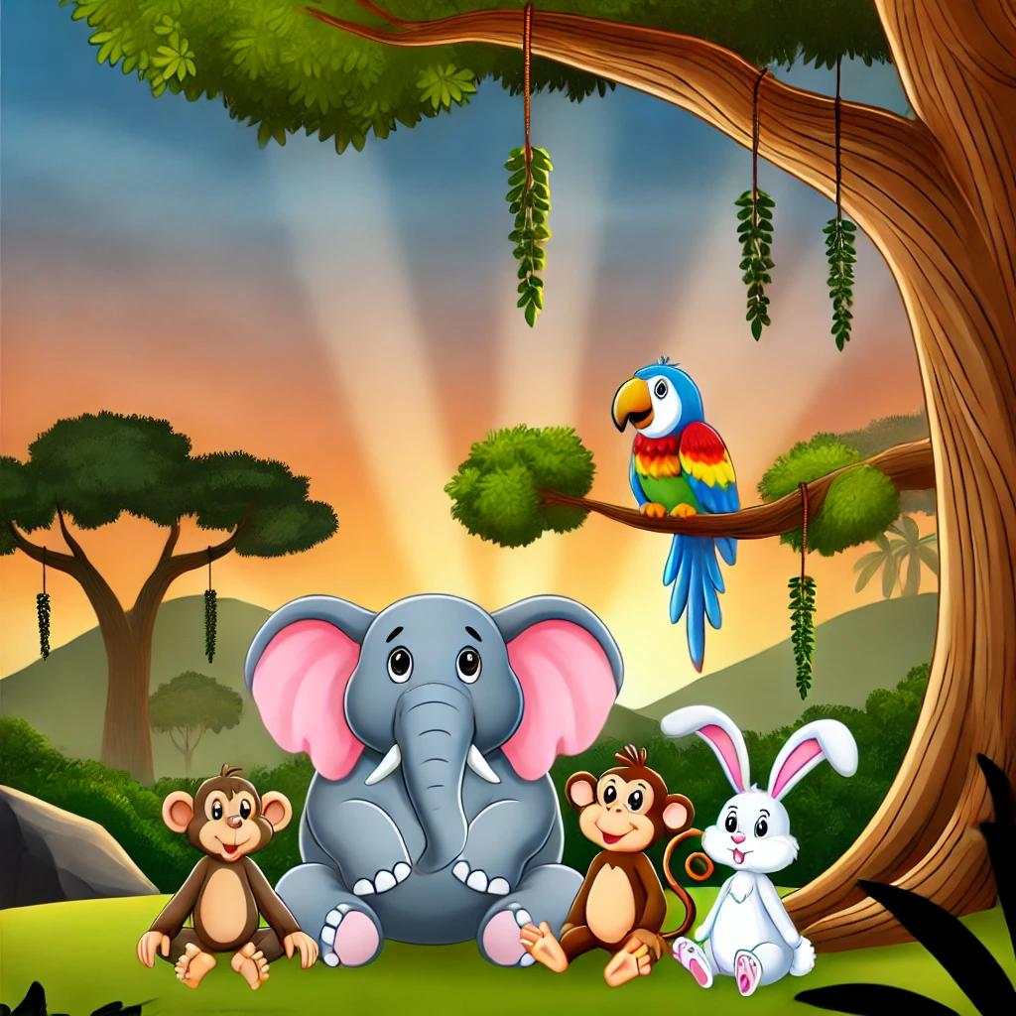

In the middle of a bright, green jungle, there lived a gentle elephant named Elly. Elly was different from other elephants; she was very kind and loved to help. All the animals knew they could count on Elly because she always had a good idea and a gentle smile.

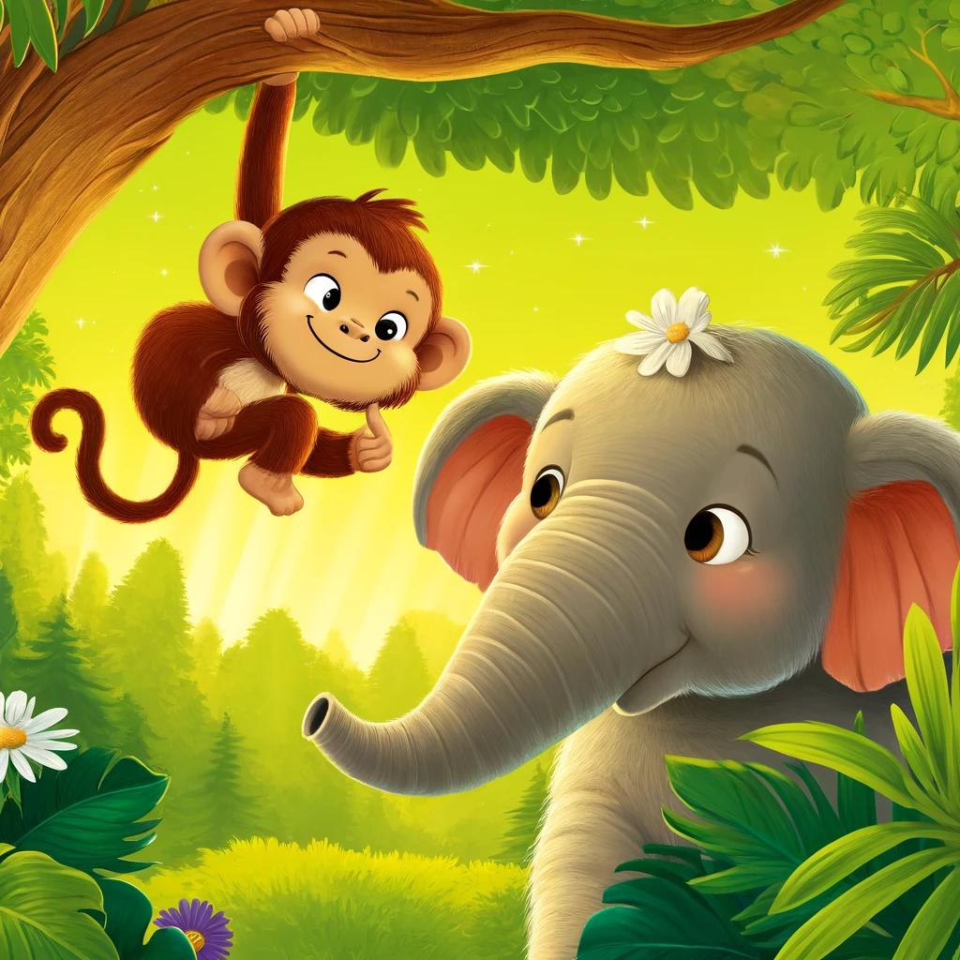

One sunny morning, Benny the monkey swung down from a branch, grinning from ear to ear. “Elly,” he whispered, “I have a fun idea! Let’s play a trick on Timmy the rabbit! It’ll be so funny!”

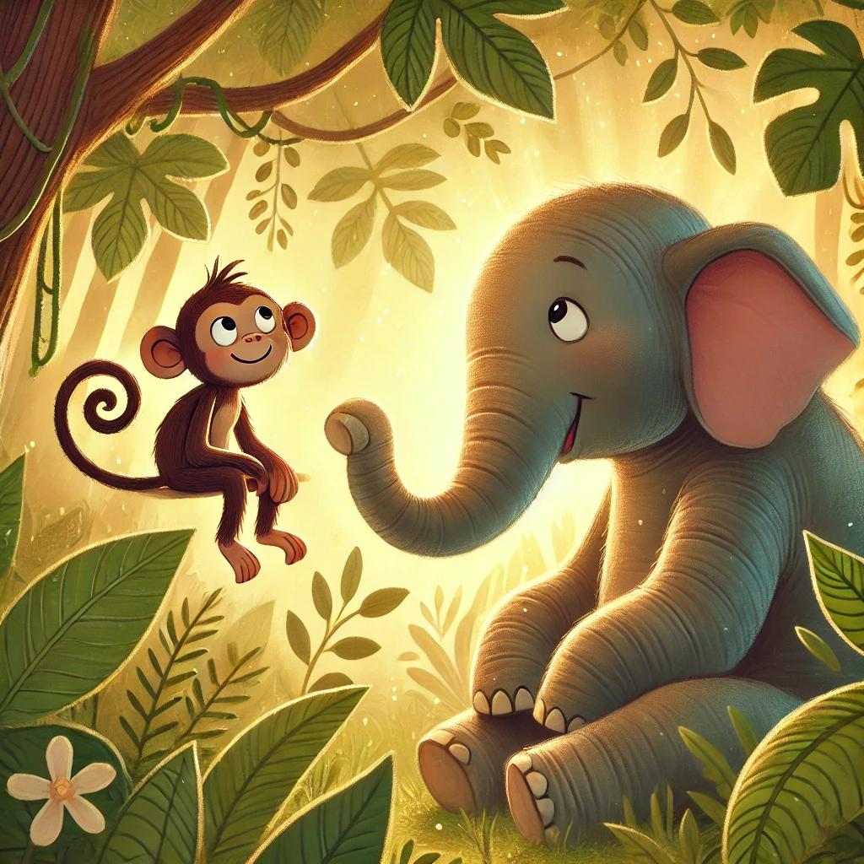

Elly thought about Benny’s idea and then gently shook her head. “Benny,” she said kindly, “tricks are only fun when everyone laughs together. Timmy might get scared. Instead, why don’t we do something nice for him?”  
Benny scratched his head and thought. “Hmm,” he said, “I hadn’t thought of that.”

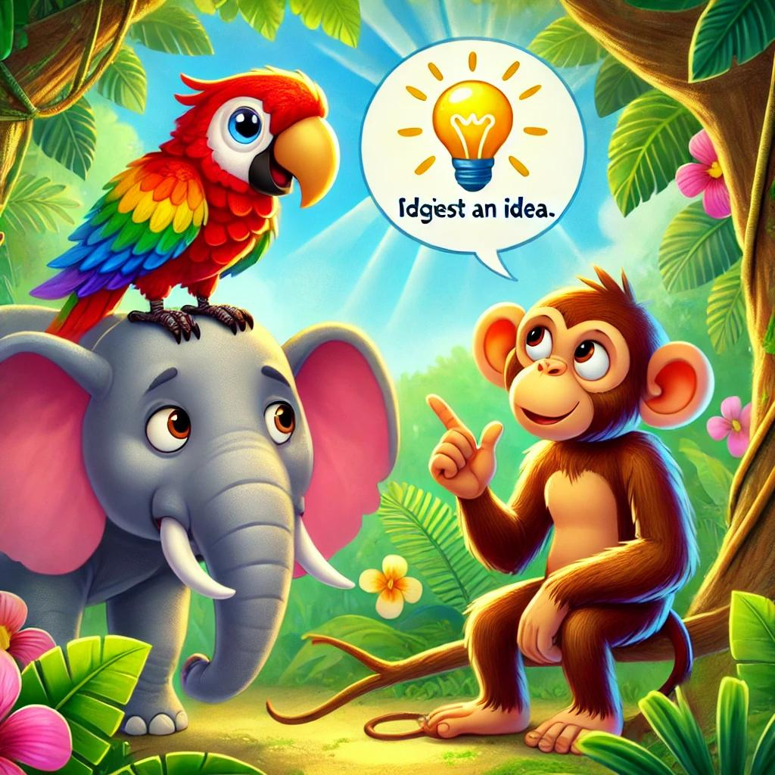

Just then, Lola the parrot swooped down from a branch. “I heard you talking about a trick! What if we make it a fun surprise instead?” she chirped happily. Lola loved to help and thought surprises were even better than tricks.

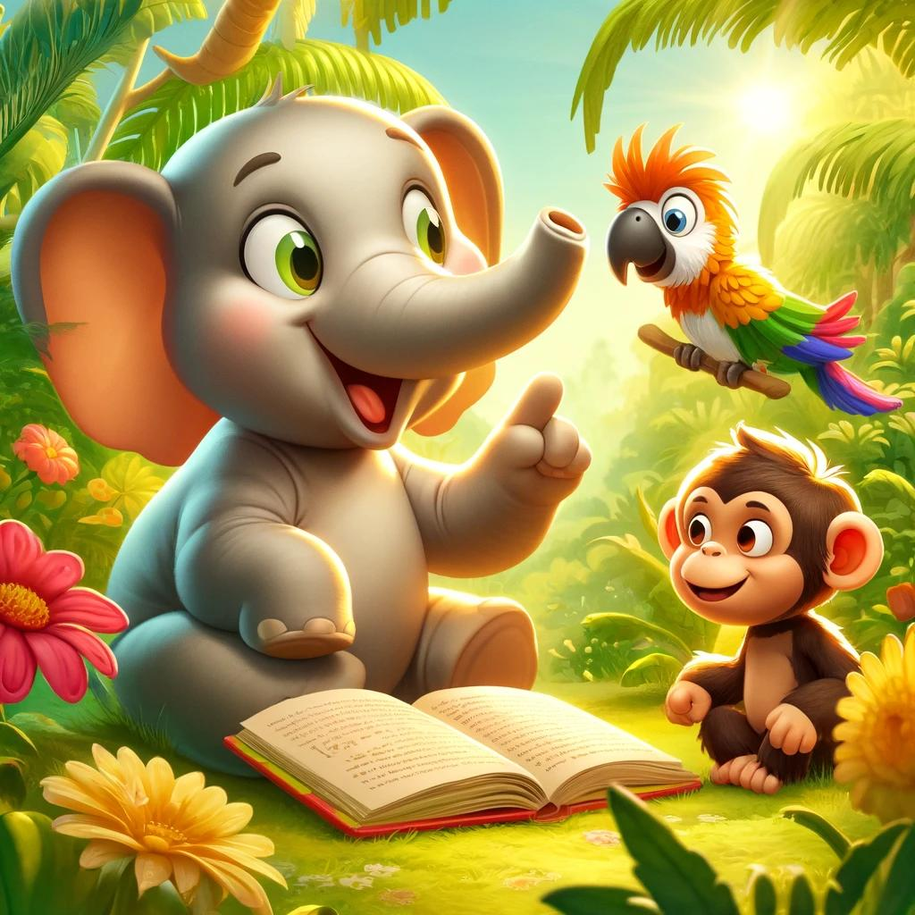

Elly’s eyes sparkled with happiness. “That’s a great idea, Lola! Timmy has been wanting to make new friends, and we could throw him a special party to show him how much he means to us!”

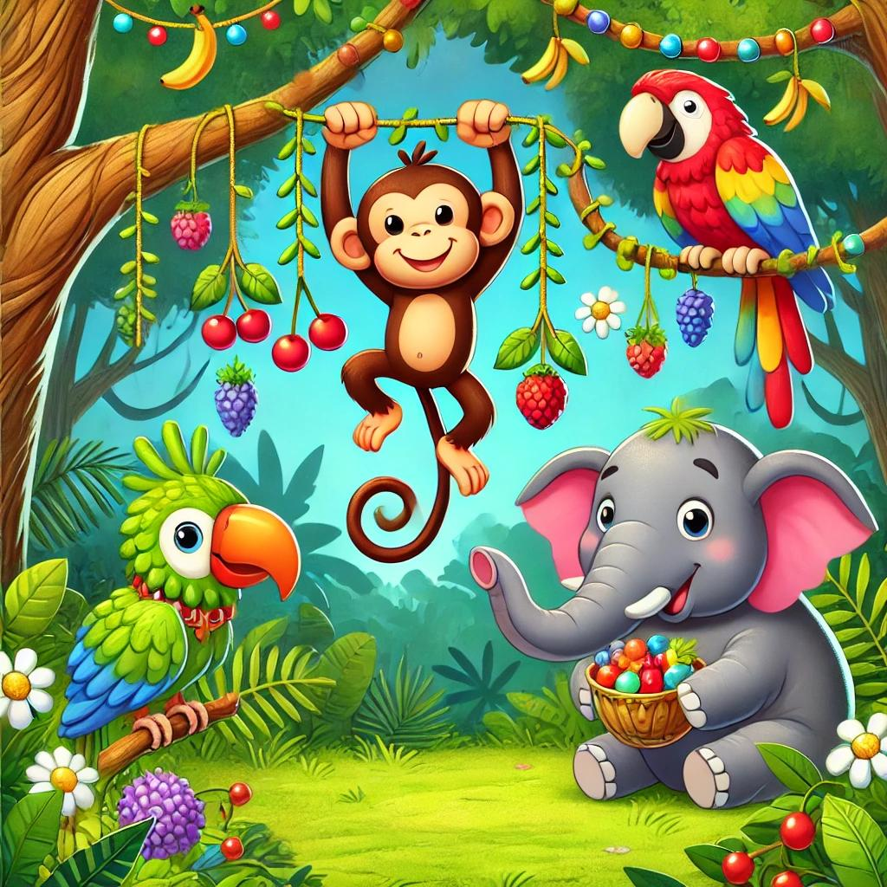

Benny jumped into action, swinging through the trees, hanging colorful vines and branches. Lola gathered berries in all sorts of colors. Elly picked beautiful flowers to make a crown, just for Timmy.

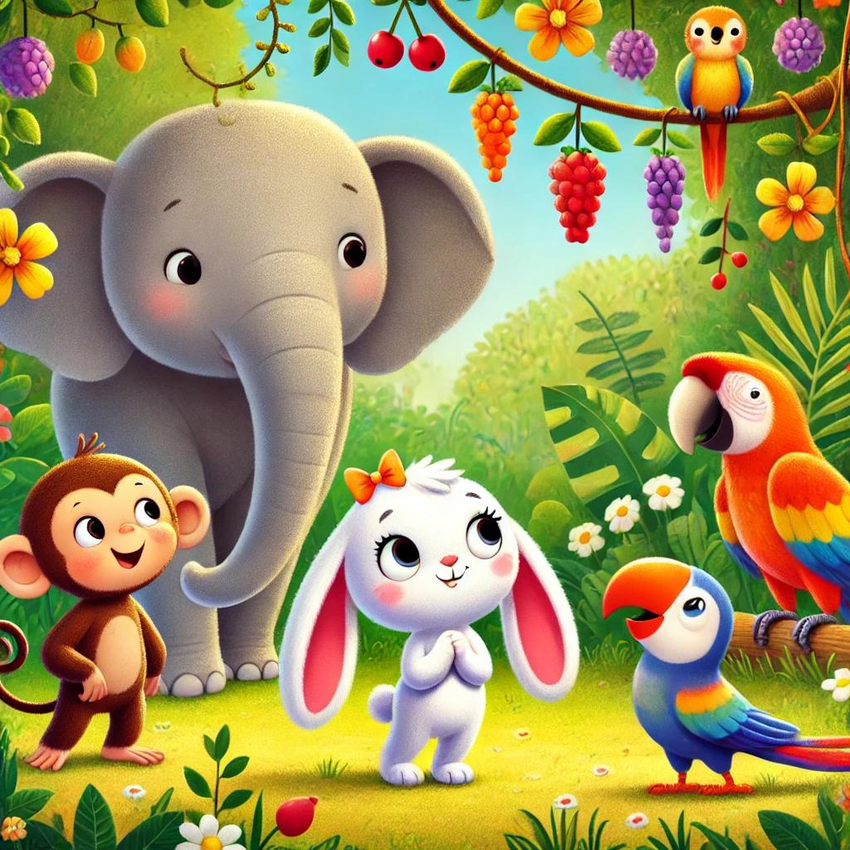

When everything was ready, Elly called out to Timmy, who was nearby. Timmy hopped over, and his eyes widened when he saw the colorful decorations. “Is… is this for me?” he asked, his little heart filling with happiness.

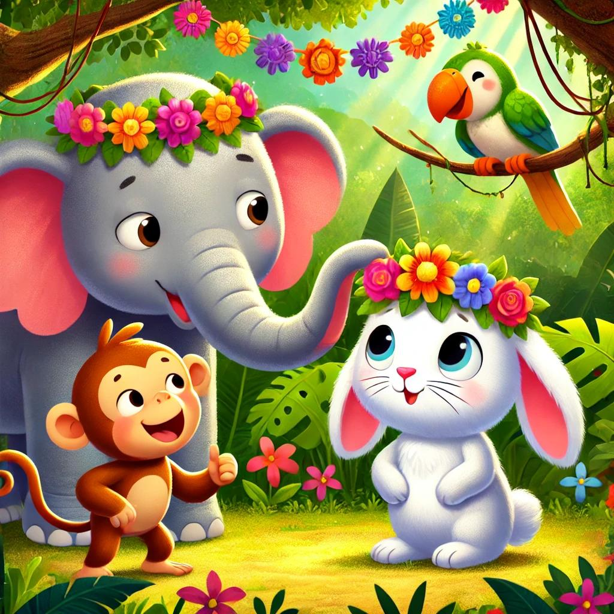

Elly knelt down and placed the flower crown she made on Timmy’s head. “Yes, Timmy! We wanted to make you feel special because you’re our friend!” Timmy smiled, feeling happier than ever.

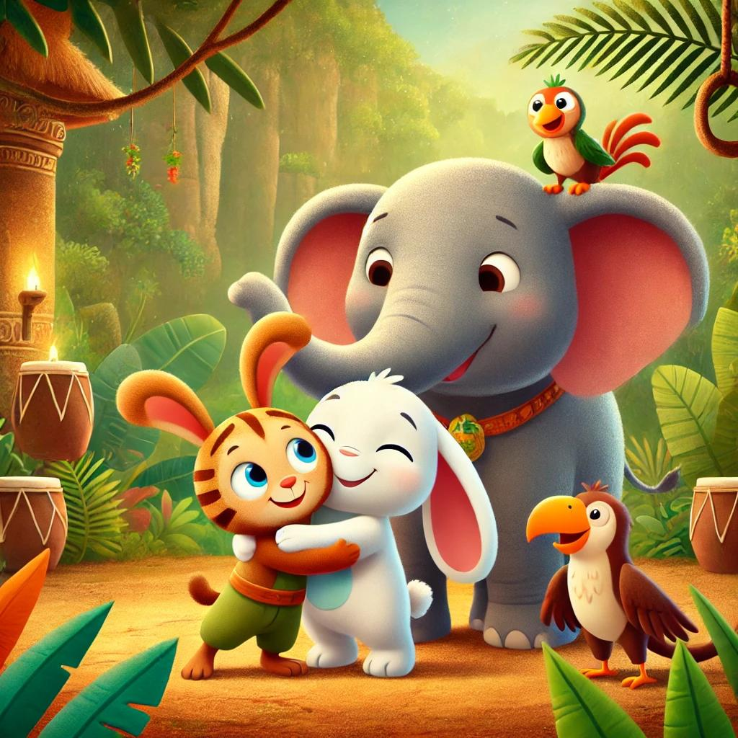

Timmy looked at all his friends with a big smile. “This is the best day ever,” he said, feeling so grateful to have friends who cared about him.

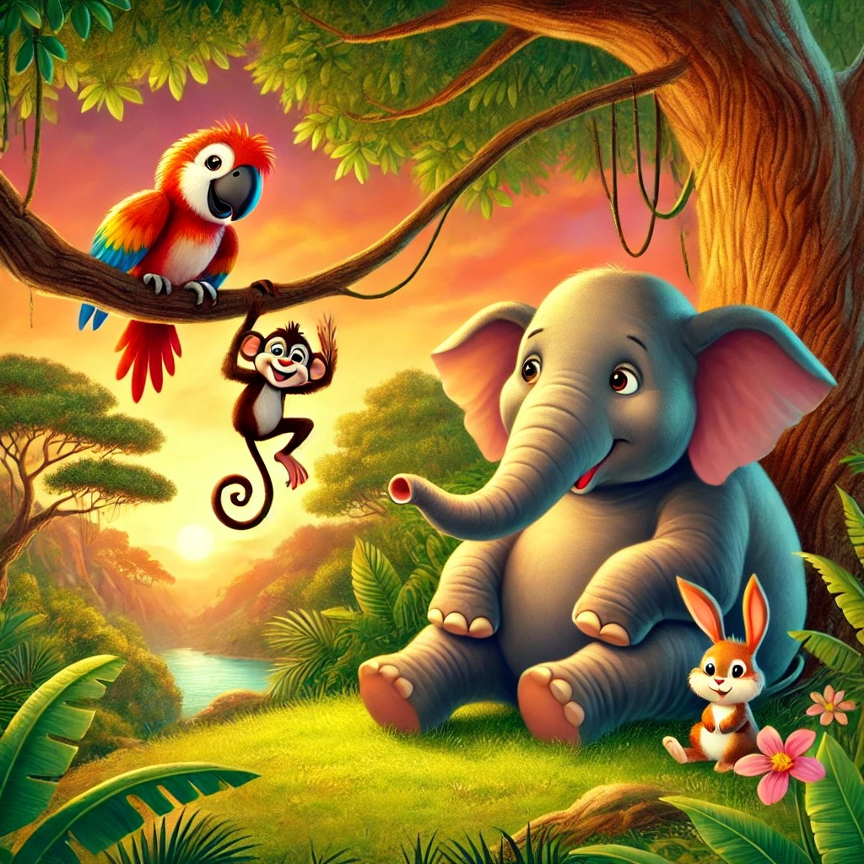

From that day on, Benny, Lola, and Timmy remembered Elly’s wise words about kindness. They learned that small acts of thoughtfulness could bring so much happiness. And they were all grateful for Elly, their wise friend, who made the jungle a better place for everyone.

# Elly the Kind Elephant: The Search for Lost Little Ones

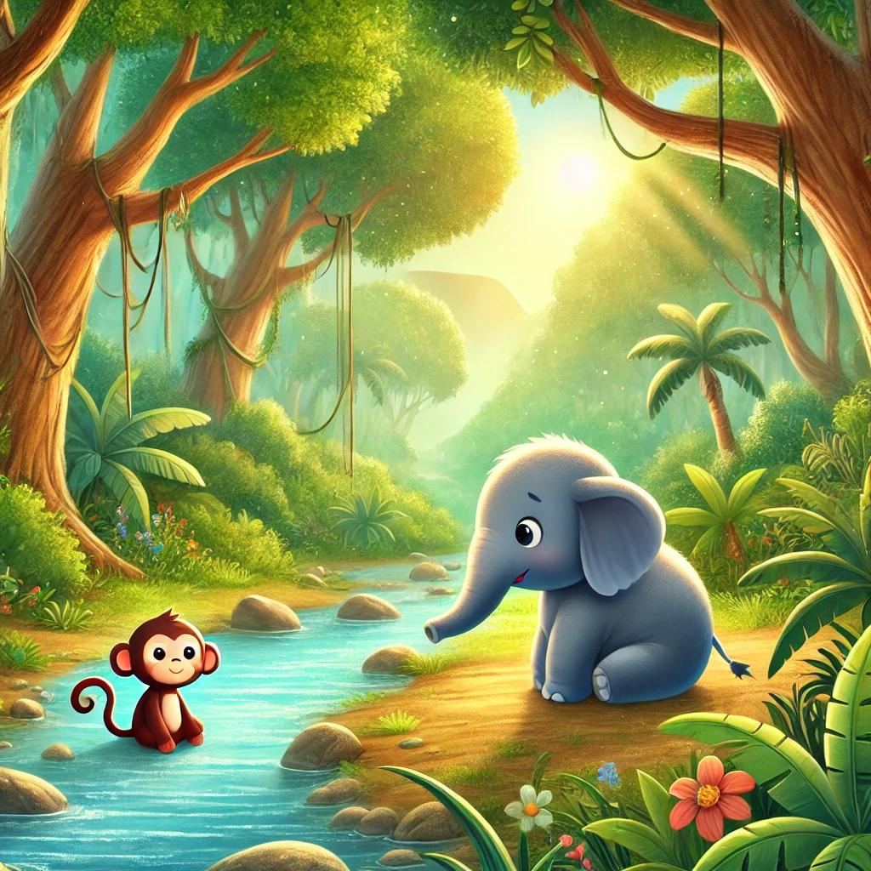

In the middle of the jungle, there lived a kind elephant named Elly. Elly was always ready to help her friends. One bright morning, Elly heard someone crying near the river.

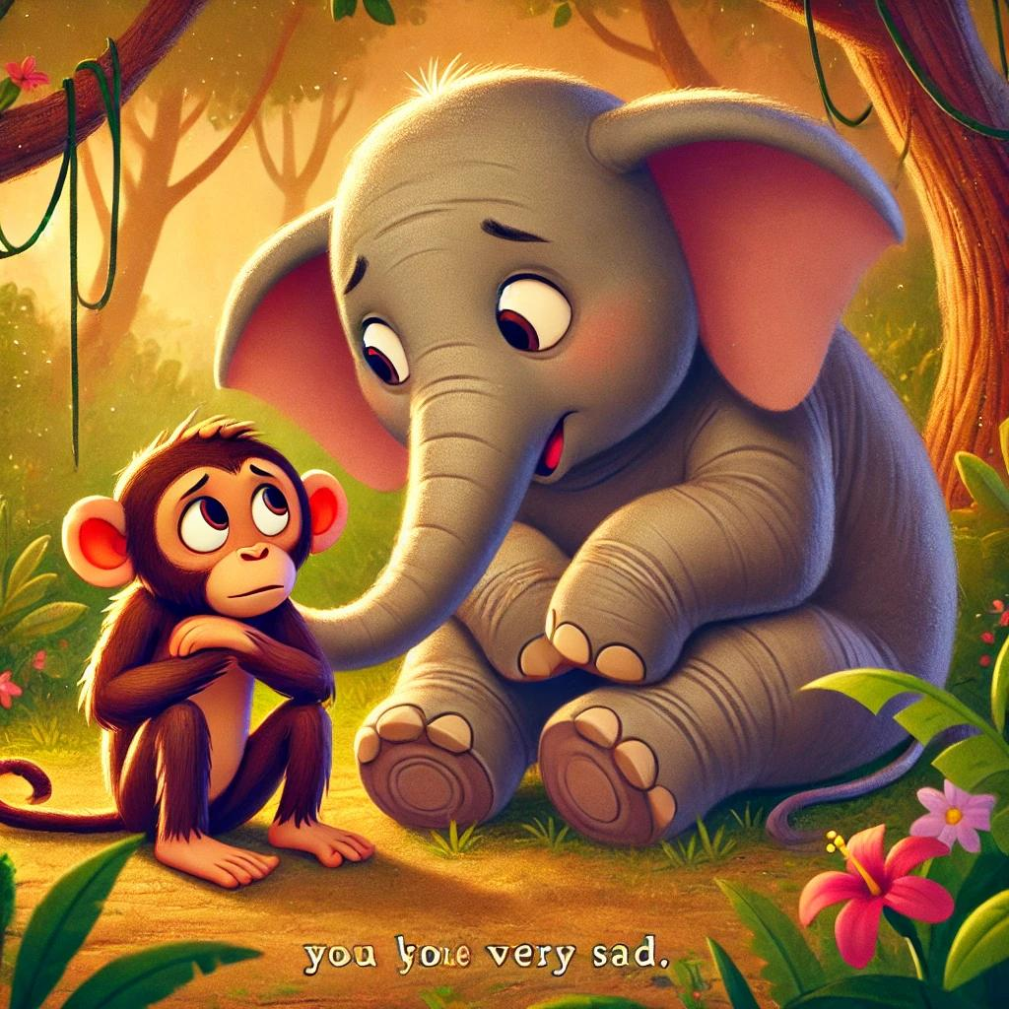

Elly walked over and saw her friend, Maya the monkey. “Maya, what’s wrong?” Elly asked gently. Maya sniffled, “It’s my baby, Max. I can’t find him anywhere!”

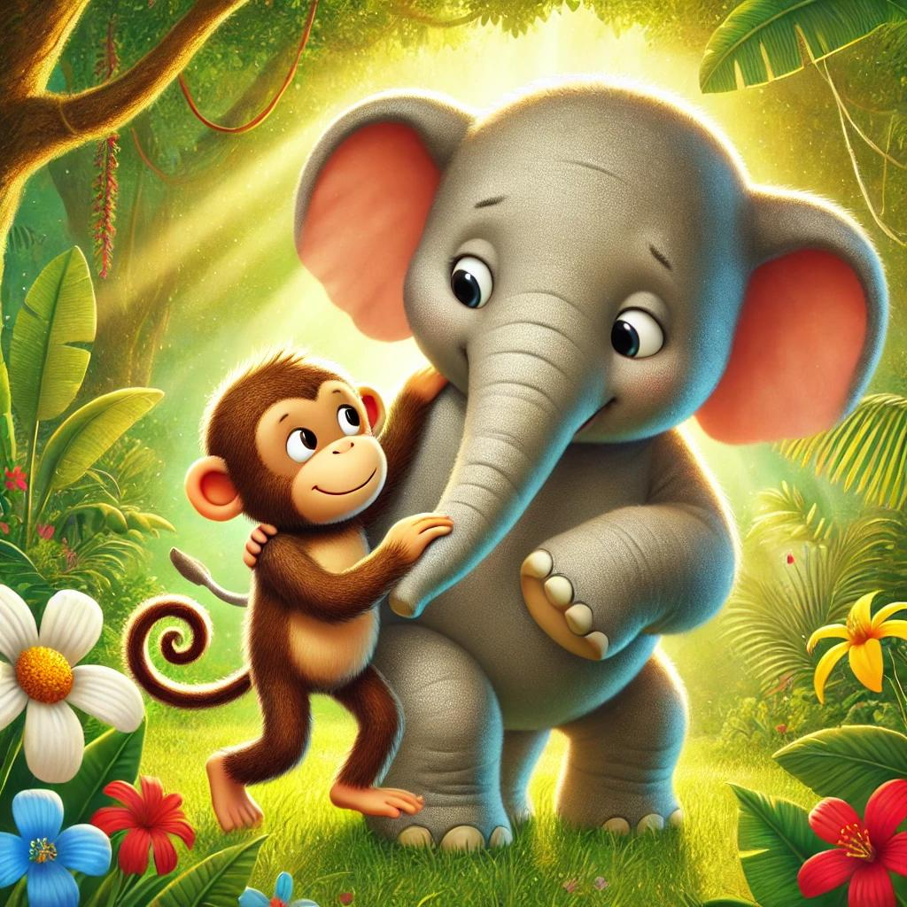

Elly wrapped her trunk around Maya. “Don’t worry,” Elly said kindly. “We’ll find Max together. Let’s start looking, and we’ll ask our friends to help us.”

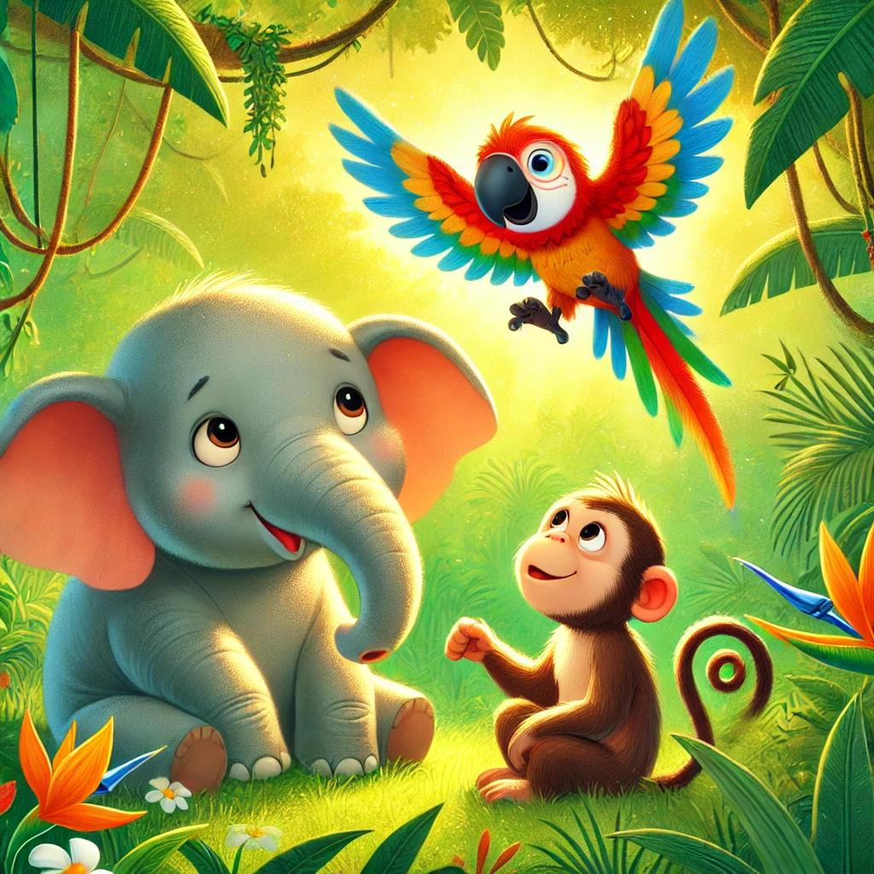

As they walked, they saw Paco the parrot flying in circles. “Paco, are you okay?” Elly asked. Paco flapped his wings. “No! My baby, Pip, is missing! I can’t find him!”

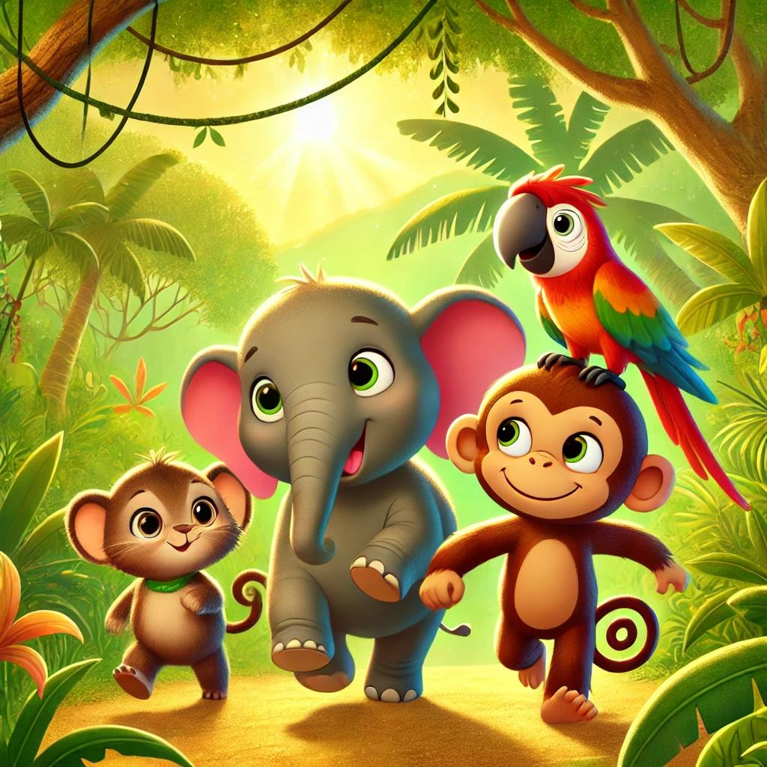

Elly said, “Join us! We’re looking for Max too. Let’s find Pip together!” Paco nodded, feeling better with his friends by his side.

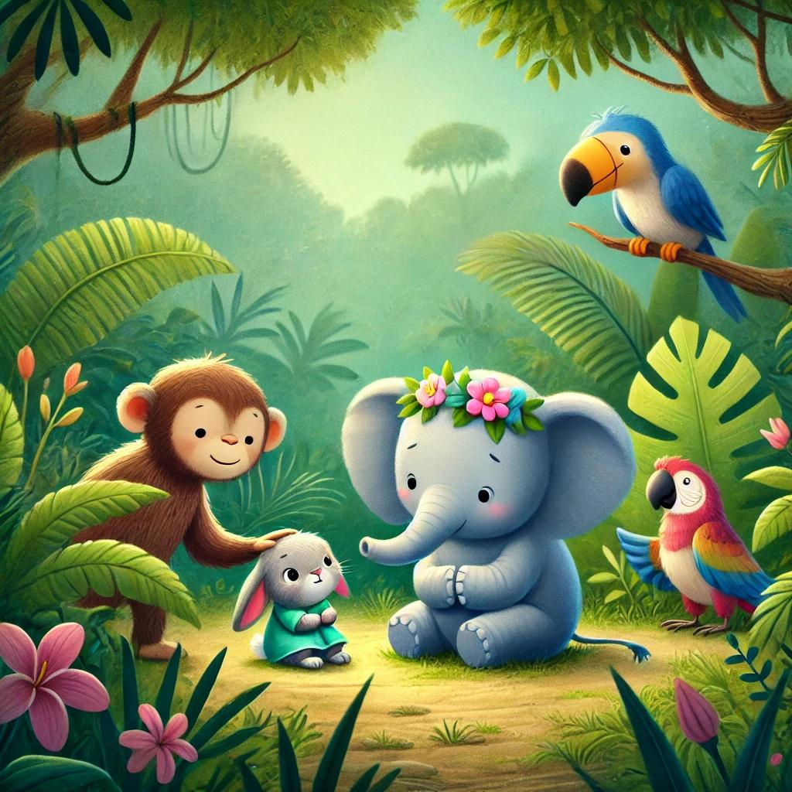

Soon, they found Lila the rabbit, looking very sad. “Lila, what happened?” asked Elly. Lila sighed, “My baby, Lulu, is lost too. I don’t know where she went!”

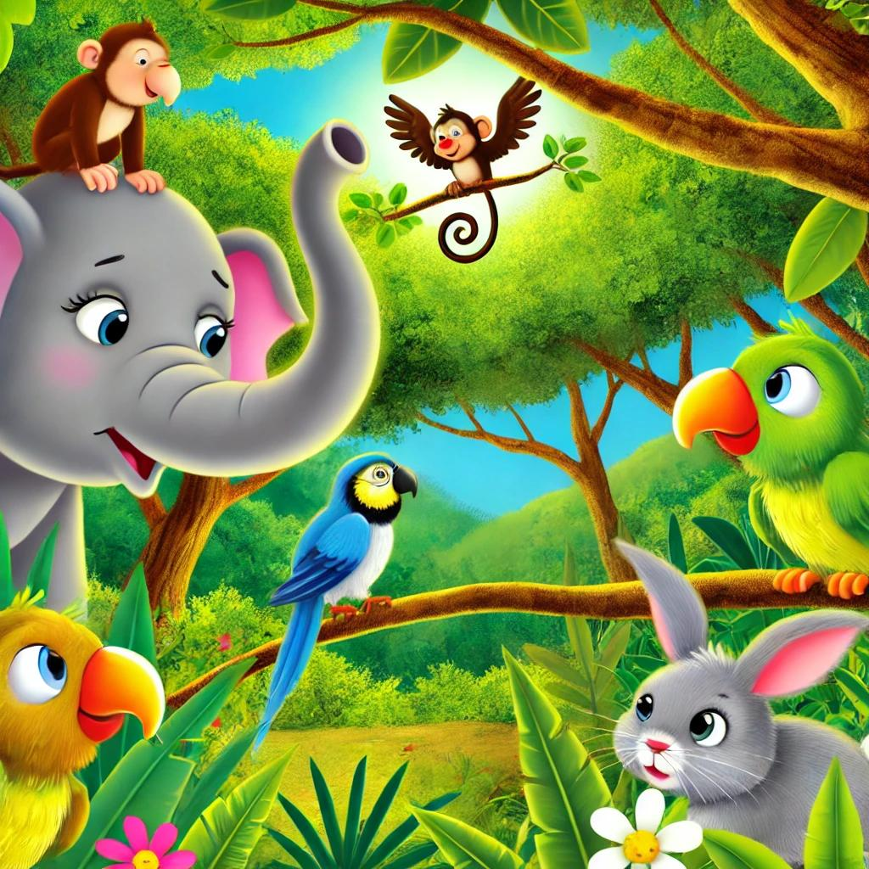

“Come with us,” said Elly. “The jungle is big, but we’ll find Max, Pip, and Lulu together!” Lila smiled and joined the group.



With Toto’s help, they soon found Max climbing a tree, Pip chirping on a branch, and Lulu hiding in some bushes. All the babies were safe!



Elly gathered everyone together. “We did it!” she said. “When we help each other, we can solve any problem.” All the friends smiled, grateful for Elly and each other.



From that day on, Benny, Lola, and Timmy remembered Elly’s words about kindness. They learned that true friends bring each other joy and make each other feel loved.

# Elly the Brave Elephant: A Journey Through the Hidden Valley

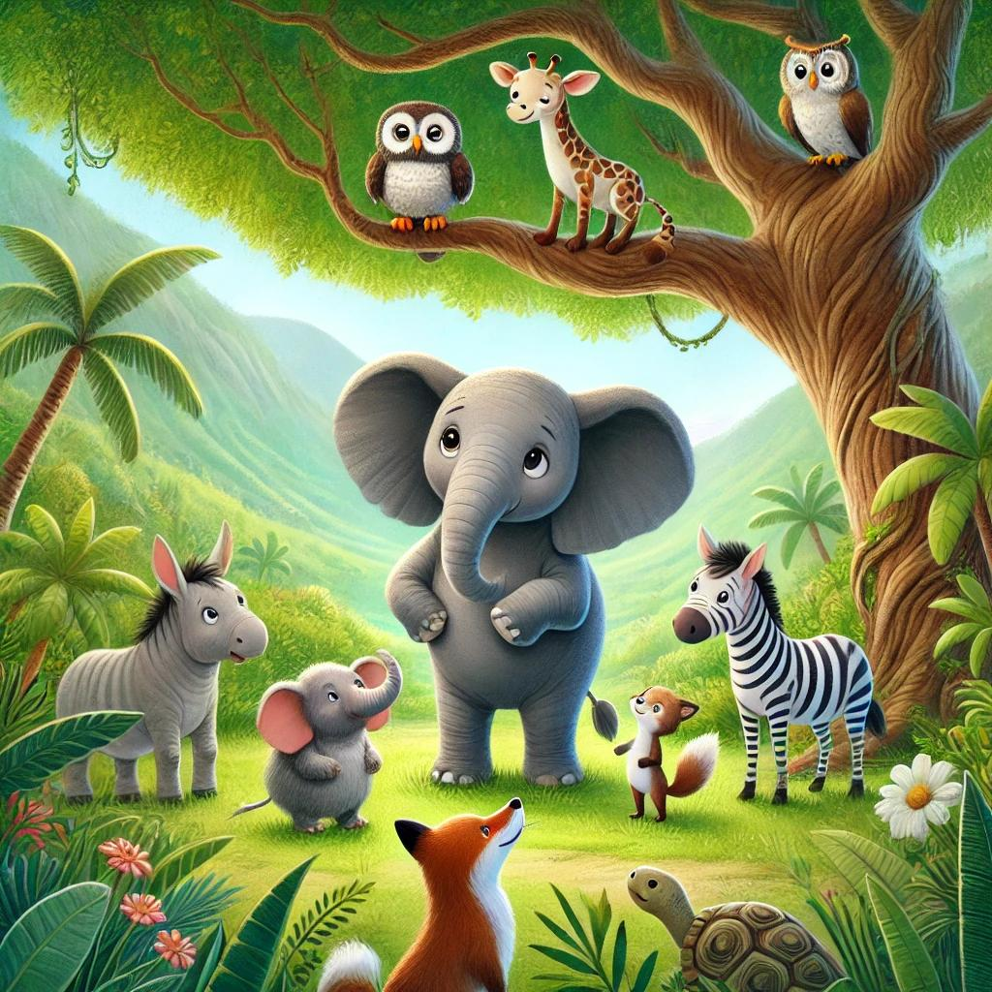

One day, Elly the elephant heard whispers about a magical place deep in the jungle called the Hidden Valley. Elly was brave, and she wanted to explore it! She gathered her friends, knowing they would need each other for this exciting journey.

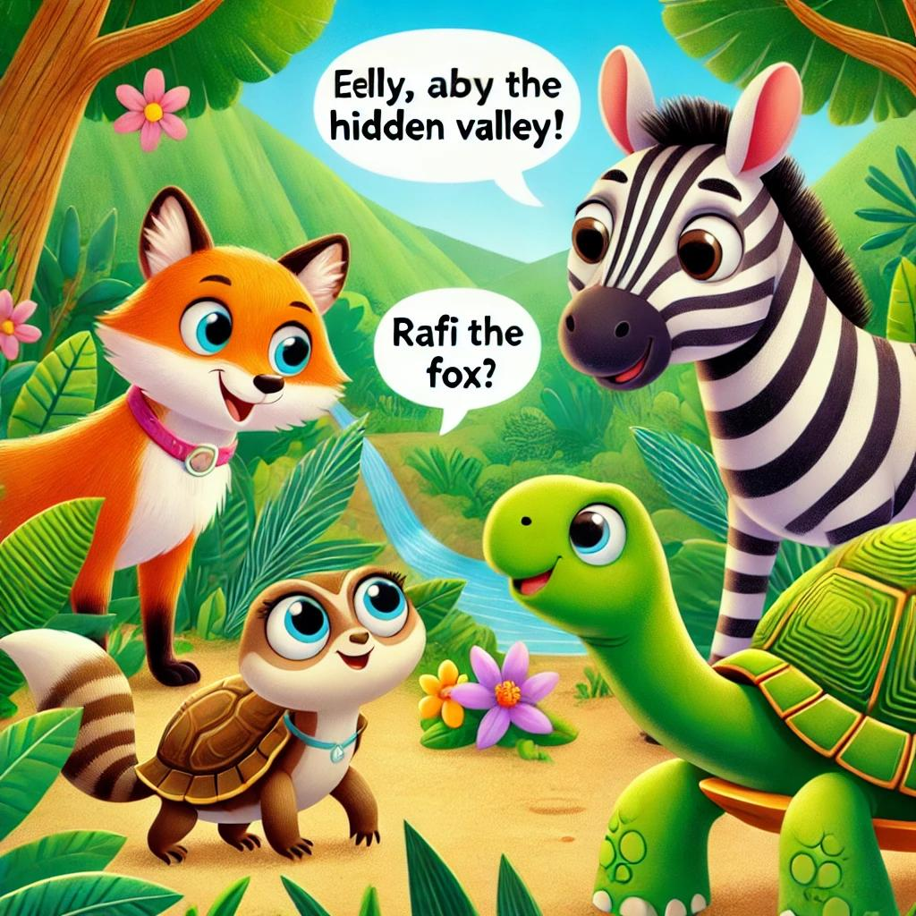

“Are we really going to the Hidden Valley?” asked Zara the zebra with big, curious eyes. Rafi the fox grinned, saying, “I’ve heard it’s full of amazing things!” Tara the tortoise nodded, “Yes, but we must stay close. The Hidden Valley can be tricky.”

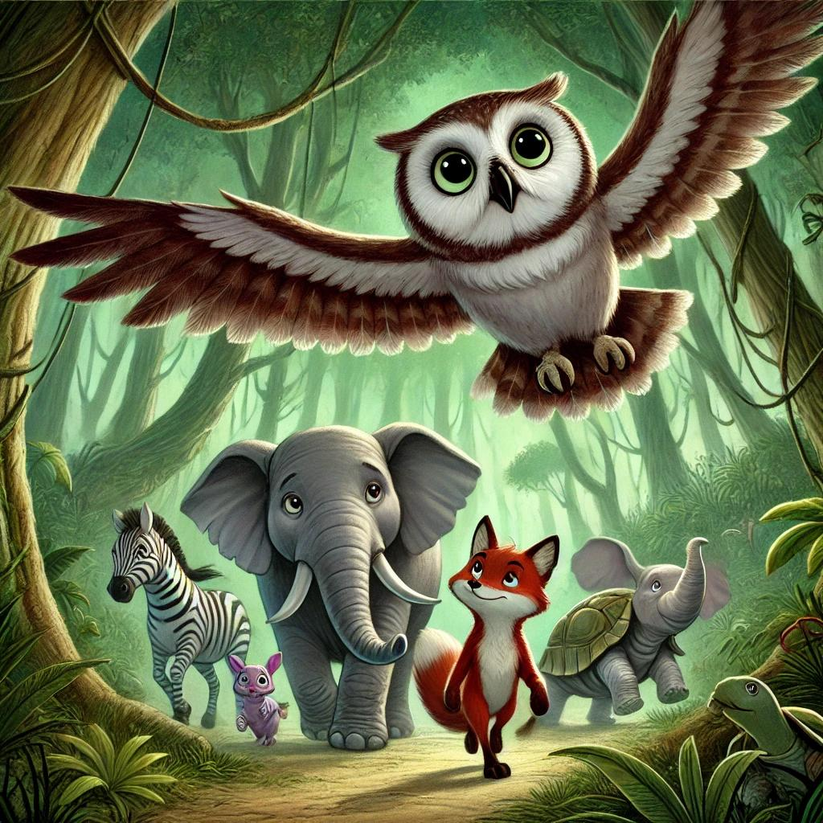

As they walked, Milo the owl flew ahead, scouting for danger. “Stay close,” he said softly. “The Hidden Valley is a place few animals know well.”

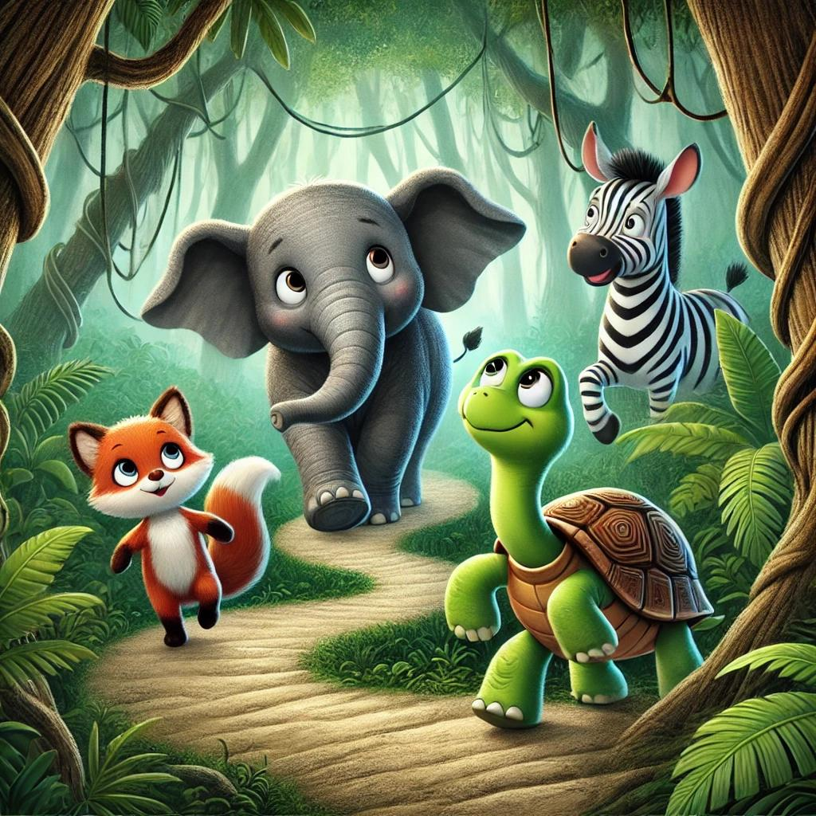

After a while, they reached a narrow, twisty path. Elly took a deep breath and stepped forward, leading the way. She felt both excited and a little nervous about what they would find.

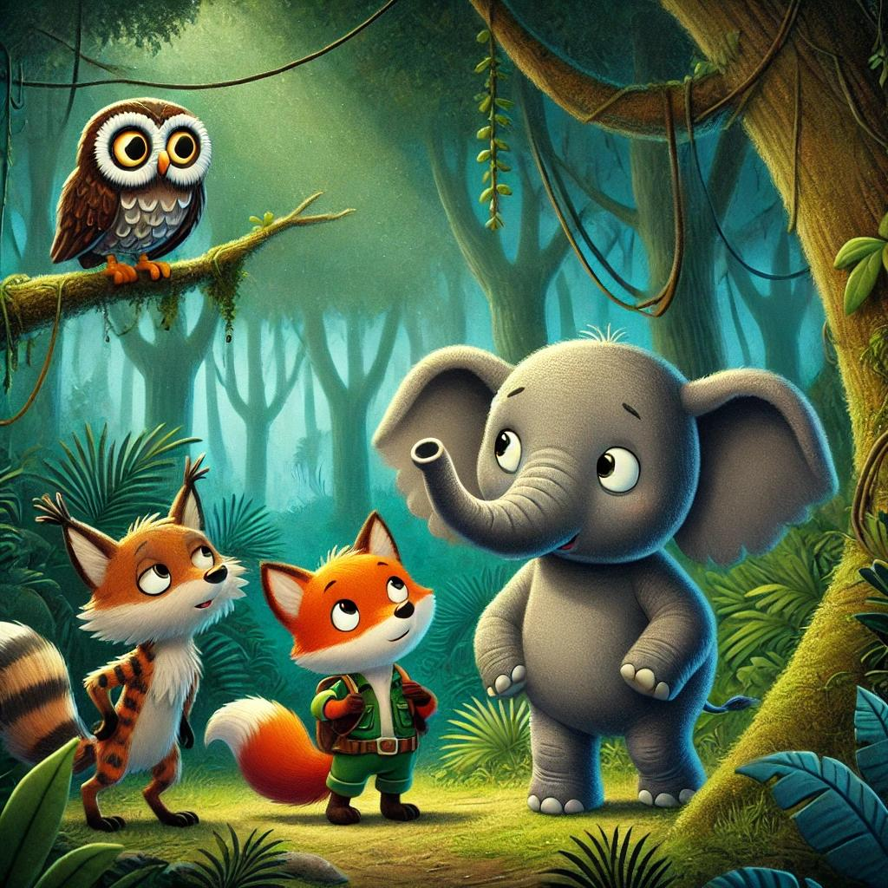

Suddenly, a strange sound echoed around them. Rafi’s ears perked up, and he whispered, “Did you hear that?” They all held their breath as the sound grew louder. Milo said, “It’s just the wind through the rocks! We’re getting close!”

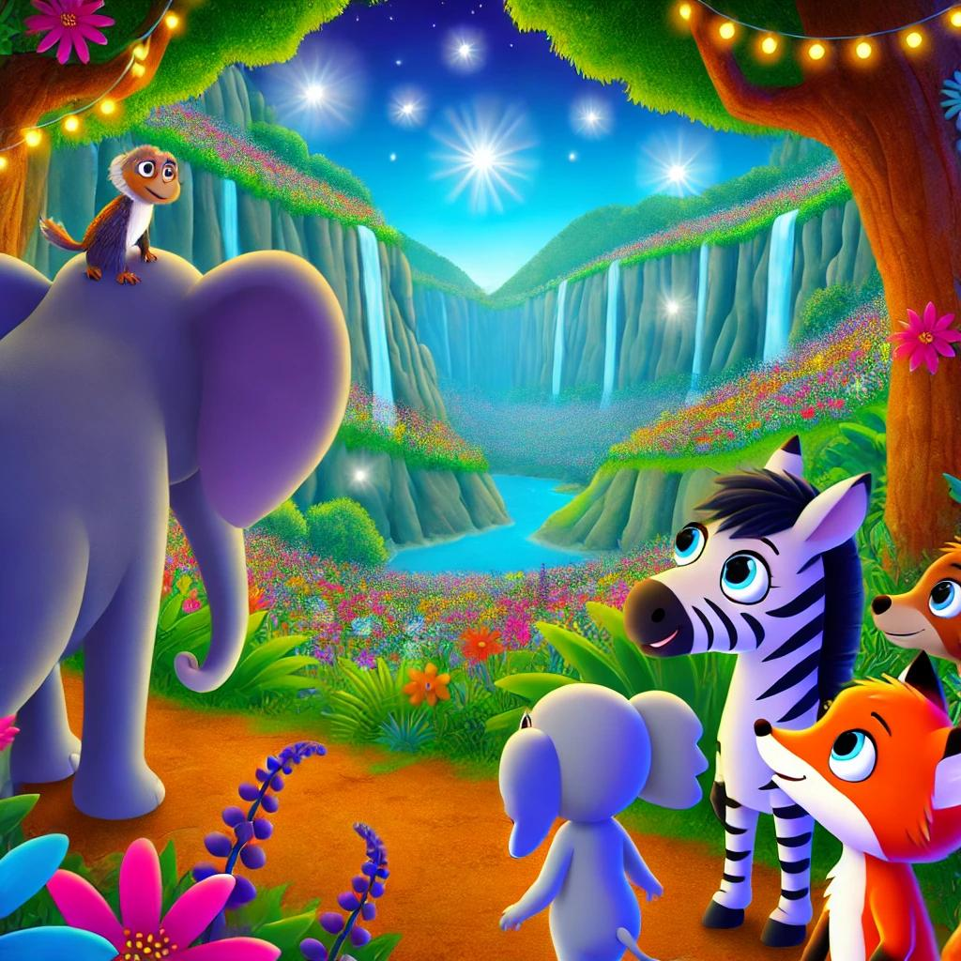

At last, they arrived at the entrance to the Hidden Valley. Before them lay a secret world with bright flowers, sparkling waterfalls, and glowing plants. They all gasped at the magical sight!



As they explored, Rafi found a shimmering stone and picked it up. “Look at this!” he said excitedly. Tara, the tortoise, warned, “That’s a Moonstone! Be careful, Rafi. It’s magical and rare!”

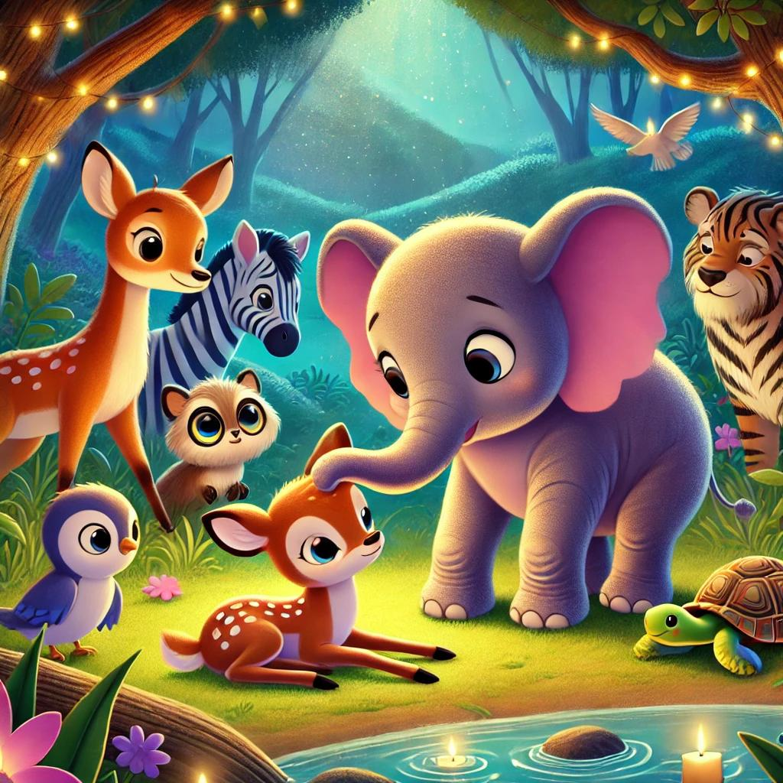

While looking around, they heard soft cries. Elly’s heart filled with kindness, and she led the way. They found a young fawn who had wandered into the valley and was lost. The little fawn looked scared.

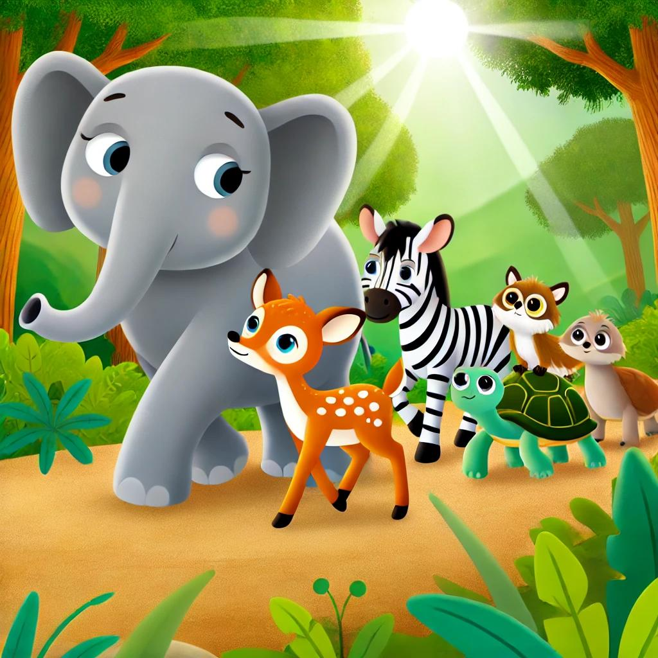

Elly and her friends promised to help the fawn get home. Together, they walked carefully back through the jungle. “With friends, we’re never alone,” Elly said, smiling.

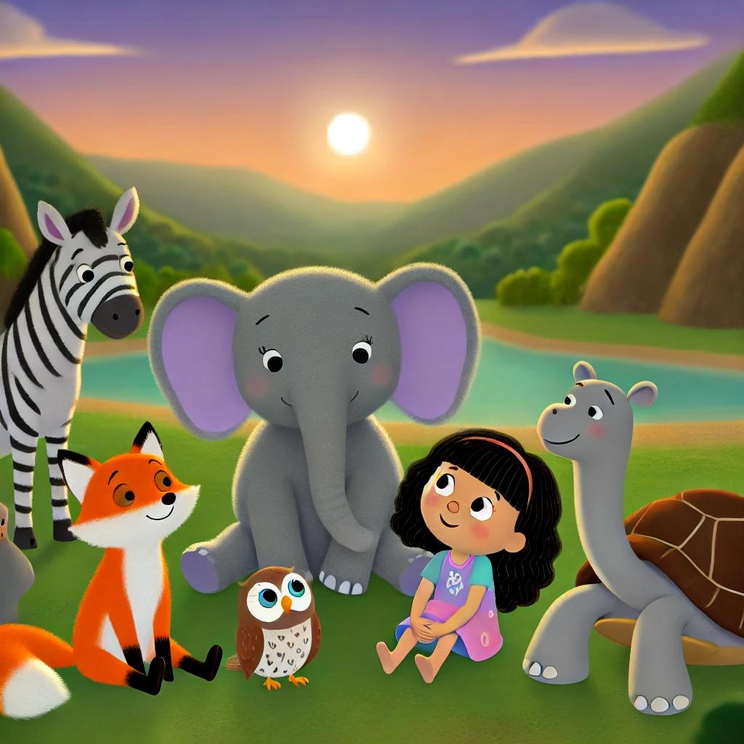

After guiding the fawn home, they returned to the Hidden Valley one last time. As the sun set, Elly said, “With bravery and friendship, we can do anything!” They all smiled, proud of their adventure.